**Institute of Computer Technology**

**B. Tech. Computer Science and Engineering**

**Semester: III**

**Sub: Database Management System**

**Course Code: 2CSE301**

**Practical Number:2**

**Objective:**

*Performing Deletion, Modifying, Altering, Updating and Viewing*

*records based on conditions on tables.*

* Scenario: Mohan is reviewing the work done till now and suggest IT Company to create one more table named Employee to have their records. They are applying CRUD Operation i.e. changes in table structure and data modified with different fields.

**Exercise:**

*Solve the following queries using the database given in practical 1.*

1. **Retrieving records from table.**
   1. **Find out the names of all clients.**

**Code :**

SELECT Name FROM client_master;

**Output :**

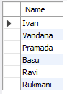

* 1. **Retrieve the list of names and the cities of all the clients**

**Code :**

SELECT Name, City FROM client_master;

**Output :**

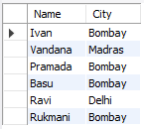

* 1. **List the various products available from the product_master table.**

**Code :**

SELECT Description FROM product_master;

**Output :**

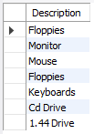

* 1. **List all the clients who are located in Bombay.**

**Code :**

SELECT * FROM client_master WHERE City = 'Bombay';

**Output :**

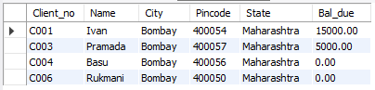

* 1. **Find the names of the salesman who have a salary equal to Rs. 3000**

**Code :**

SELECT S_name FROM salesman_master WHERE Sal_amt = 3000;

**Output :**

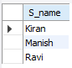

* 1. **List out only unique values for the city of client_master table**

**Code :**

SELECT DISTINCT City FROM client_master;

**Output :**

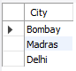

* 1. **Display product_master table according to the sell_price of product.**

**Code :**

SELECT * FROM product_master ORDER BY Sell_price;

**Output :**

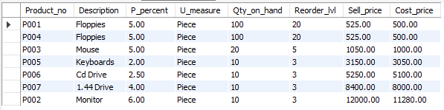

* 1. **Display product_master table according to the sell_price and cost_price.**

**Code :**

SELECT * FROM product_master ORDER BY Sell_price, Cost_price;

**Output :**

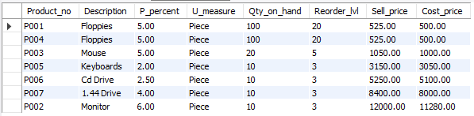

* 1. **Display product_no, description in descending order of sell_price for product_master table.**

**Code :**

SELECT Product_no, Description FROM product_master ORDER BY Sell_price DESC;

**Output :**

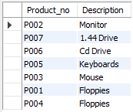

1. **Updating records in a table.**

*(Without changing shafe mode=0 any of the update code is not possible)*

* 1. **Change the city of client_no’C002’ to ‘Bombay’.**

**Code :**

UPDATE client_master SET City = 'Bombay' WHERE Client_no = 'C002';

**Output :**



* 1. **Change the bal_due of client_no’C001’ to Rs.1000**

**Code :**

UPDATE client_master SET Bal_due = 1000 WHERE Client_no = 'C001';

**Output :**



* 1. **Change the cost price of Floppies to Rs. 950.00**

**Code :**

UPDATE product_master SET Cost_price = 950.00 WHERE Description = 'Floppies';

**Output :**



* 1. **Change the city of the salesman to Mumbai.**

**Code :**

UPDATE salesman_master SET City = 'Mumbai';

**Output :**



1. **Deleting records in a table:**
   1. **Delete all salesman from the salesmane_master whose salaries are equal to Rs. 3500.**

**Code :**

DELETE FROM salesman_master WHERE Sal_amt = 3500;

**Output :**



* 1. **Delete all products from product_master where the quantity on hand is equal to 100.**

**Code :**

DELETE FROM product_master WHERE Qty_on_hand = 100;

**Output :**



* 1. **Delete from client_master where the column state holds the value ‘Tamil Nadu’.**

**Code :**

DELETE FROM client_master WHERE State = 'Tamil Nadu';

**Output :**



1. **Altering the table structure:**
   1. **Add a column called ‘telephone’ of datatype ‘number’ and size=10 to the client_master table.**

**Code :**

ALTER TABLE client_master ADD COLUMN telephone VARCHAR(10);

**Output :**



* 1. **Change the size of sell_price column in product_master to 10,2.**

**Code :**

ALTER TABLE product_master MODIFY COLUMN Sell_price DECIMAL(10,2);

**Output :**



* 1. **Rename column telephone to new name as contact for client_master table.**

**Code :**

ALTER TABLE client_master CHANGE COLUMN telephone contact VARCHAR(10);

**Output :**



* 1. **Delete column contact from client_master table.**

**Code :**

ALTER TABLE client_master DROP COLUMN contact;

**Output :**



1. **Deleting the table structure along with data:**
   1. **Create table employee with 4 columns and 5 rows.**

**Code :**

CREATE TABLE employee (

Emp_id INT,

Emp_name VARCHAR(20),

Emp_position VARCHAR(20),

Emp_salary DECIMAL(8,2)

);

INSERT INTO employee (Emp_id, Emp_name, Emp_position, Emp_salary) VALUES

(1, 'John Doe', 'Manager', 50000.00),

(2, 'Jane Smith', 'Clerk', 20000.00),

(3, 'Robert Brown', 'Assistant', 25000.00),

(4, 'Linda White', 'HR', 30000.00),

(5, 'Michael Johnson', 'Accountant', 45000.00);

**Output :**



* 1. **Destroy the table employee along with its data.**

**Code :**

DROP TABLE employee;

**Output :**



1. **Renaming the table:**
   1. **Change the name of the salesman_master table to sman_mast.**

**Code :**

ALTER TABLE salesman_master RENAME TO sman_mast;

**Output :**

